**Step 1:** download and install JDK 1.8, to ensue it is installed run “javac -version” command in terminal and verify the verion is 1.8

**Step 2:** install eclipse ide for java developers mars2 version

**Step 3:** import project from git repository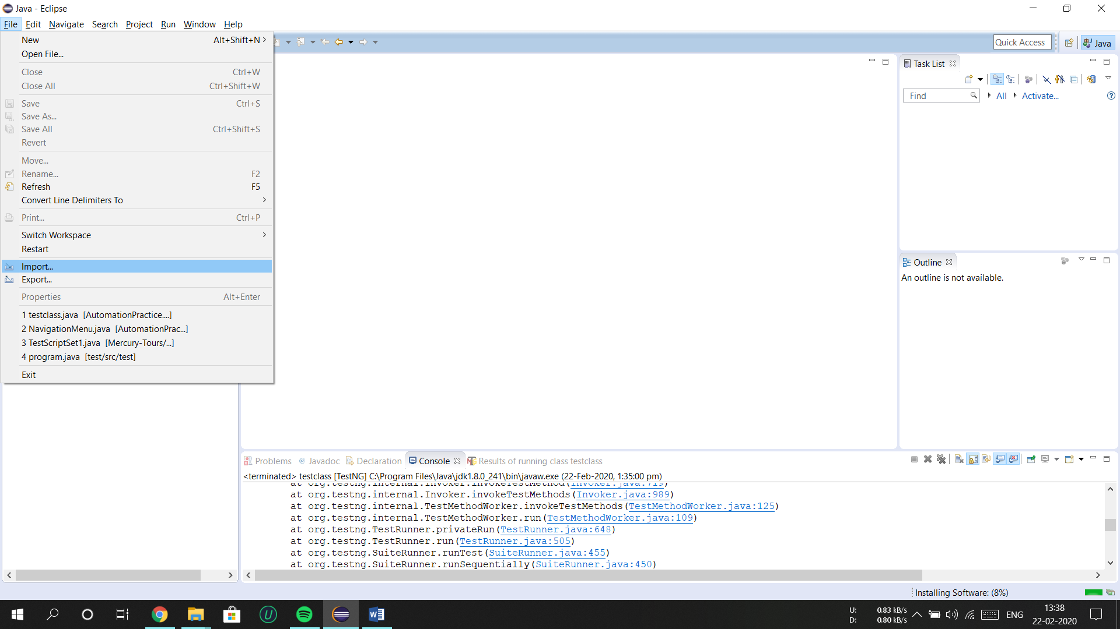

**Step 4:** choose import source as  
“GIT” then “Project from Git” 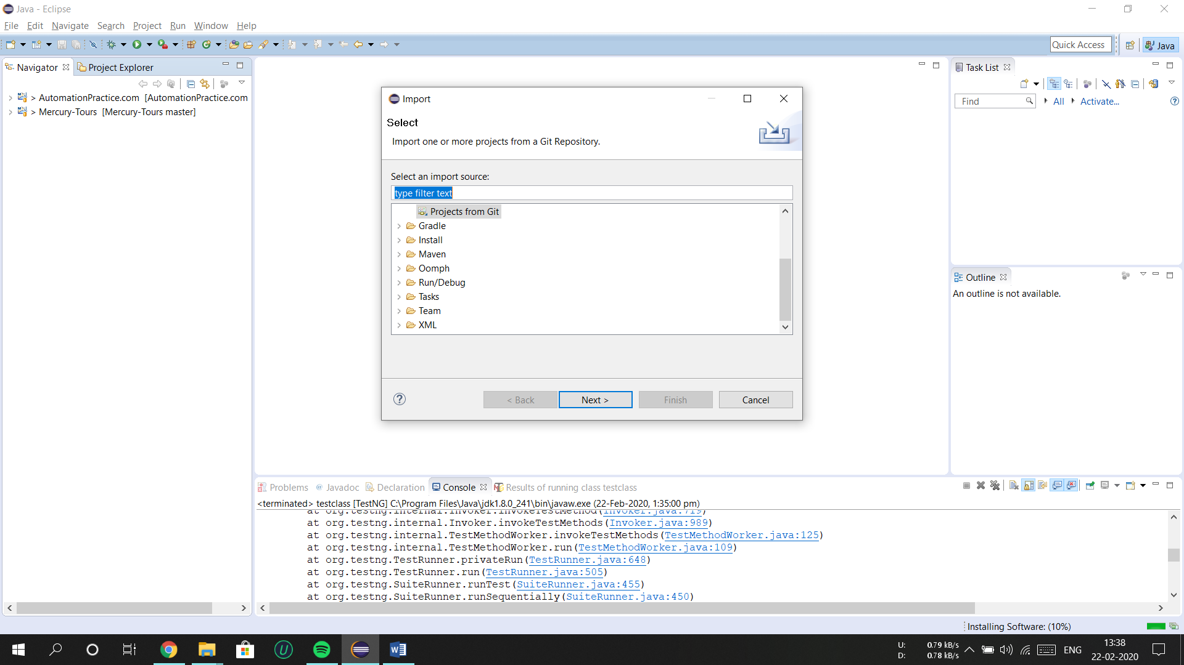

**Step 5:** then choose “Clone URI” option

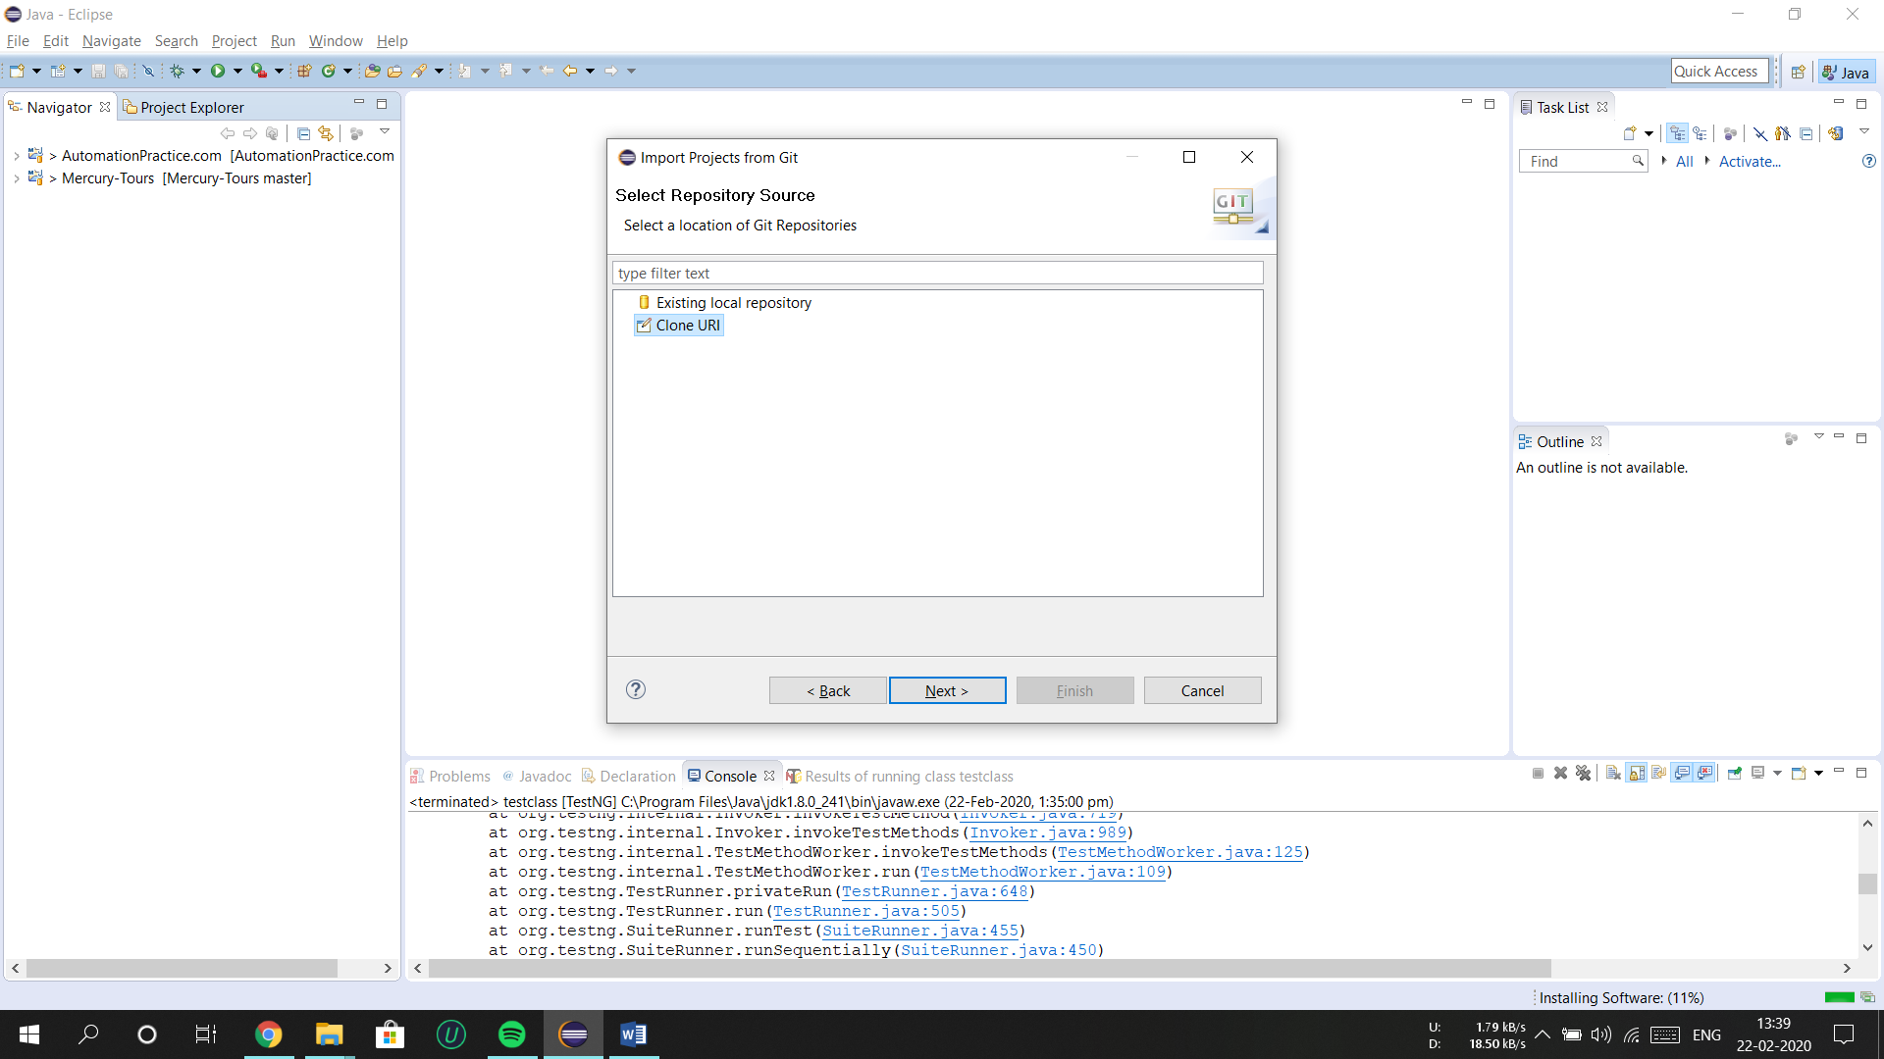

**Step 6:** copy project repository URI from GITHUB

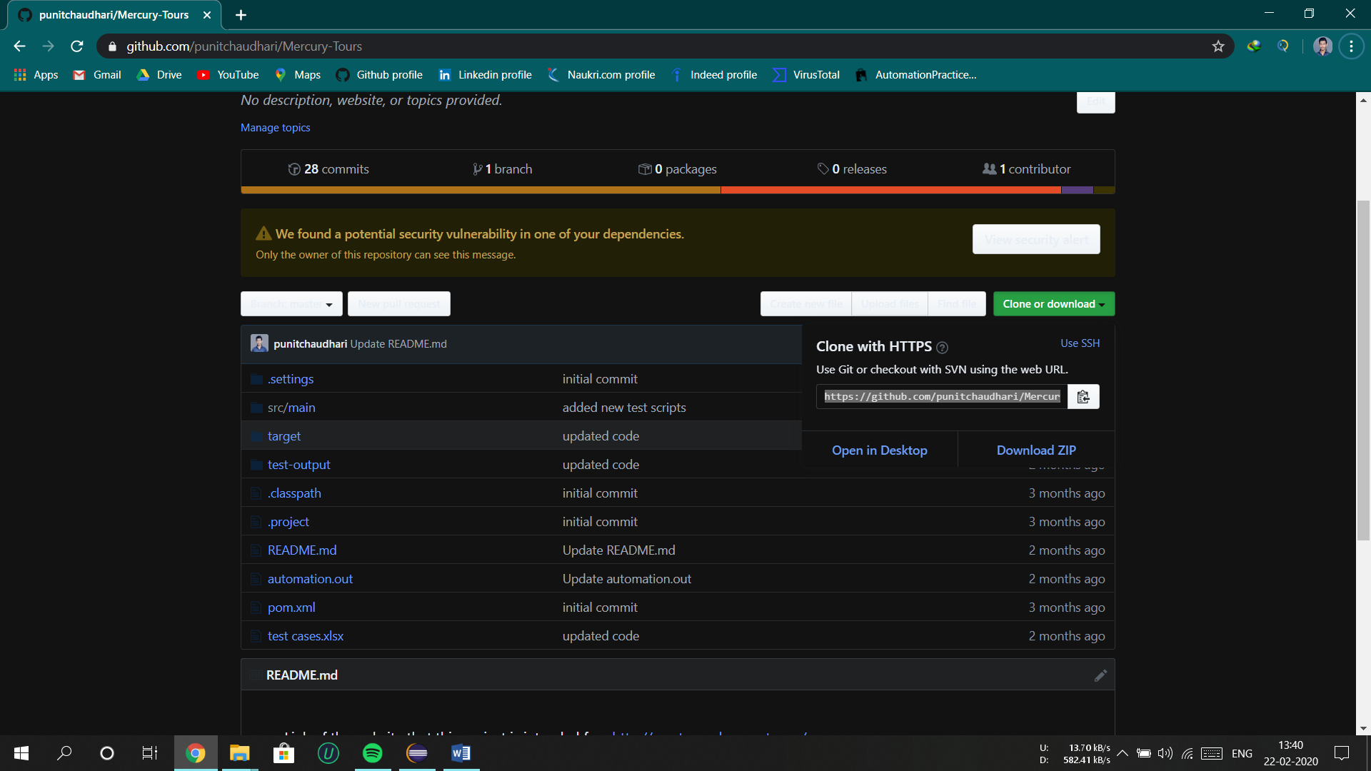

**Step 7:** paste it on URI text field and hit NEXT

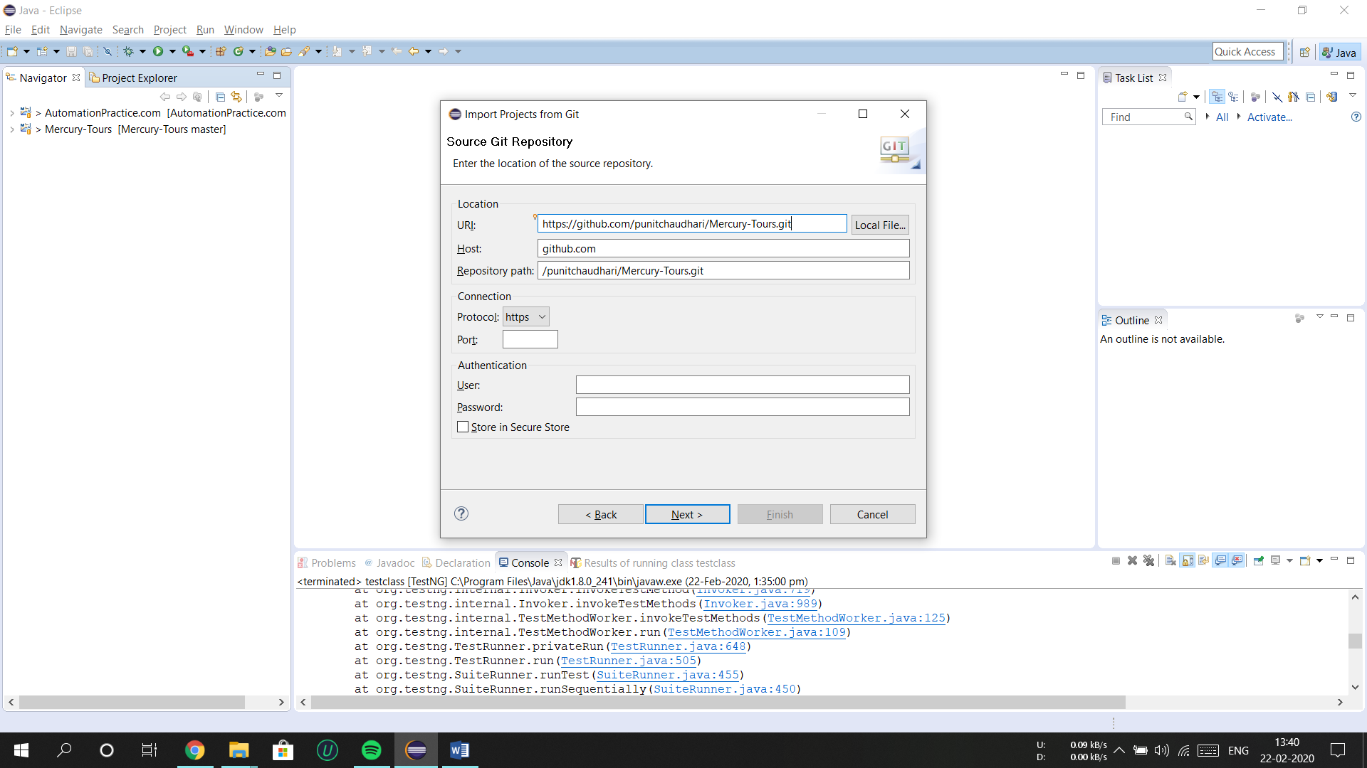

**Step 8:** hit Next again

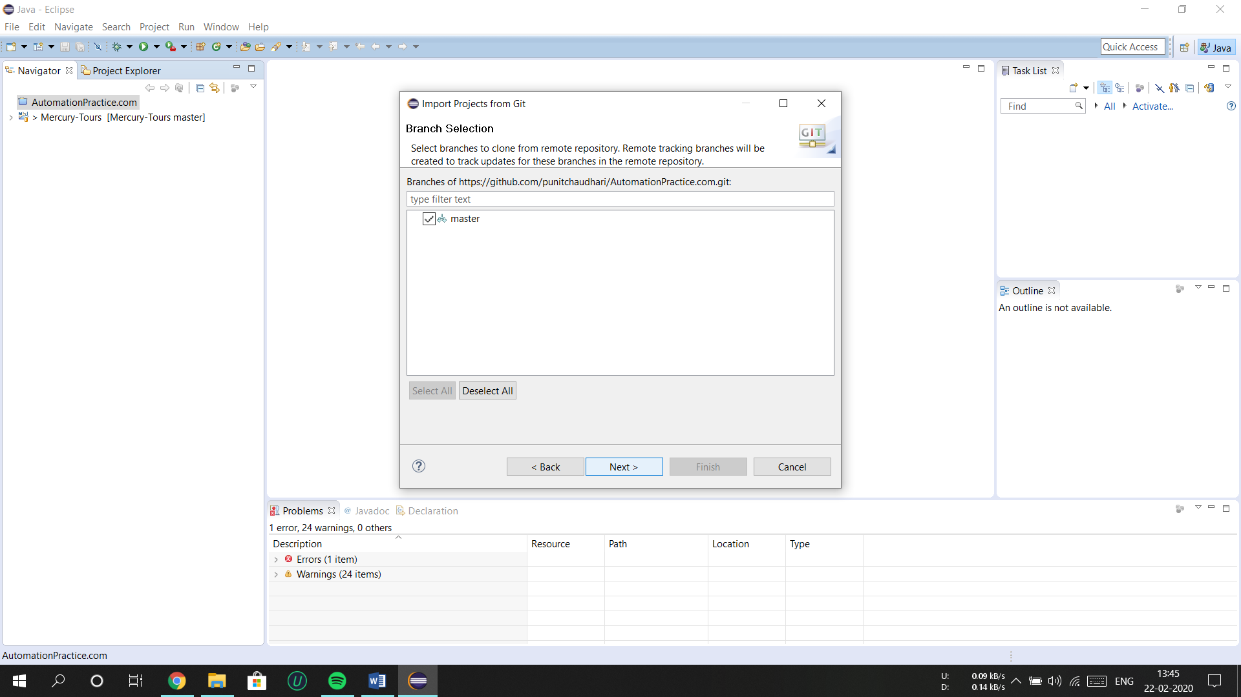

**Step 9:** hit next

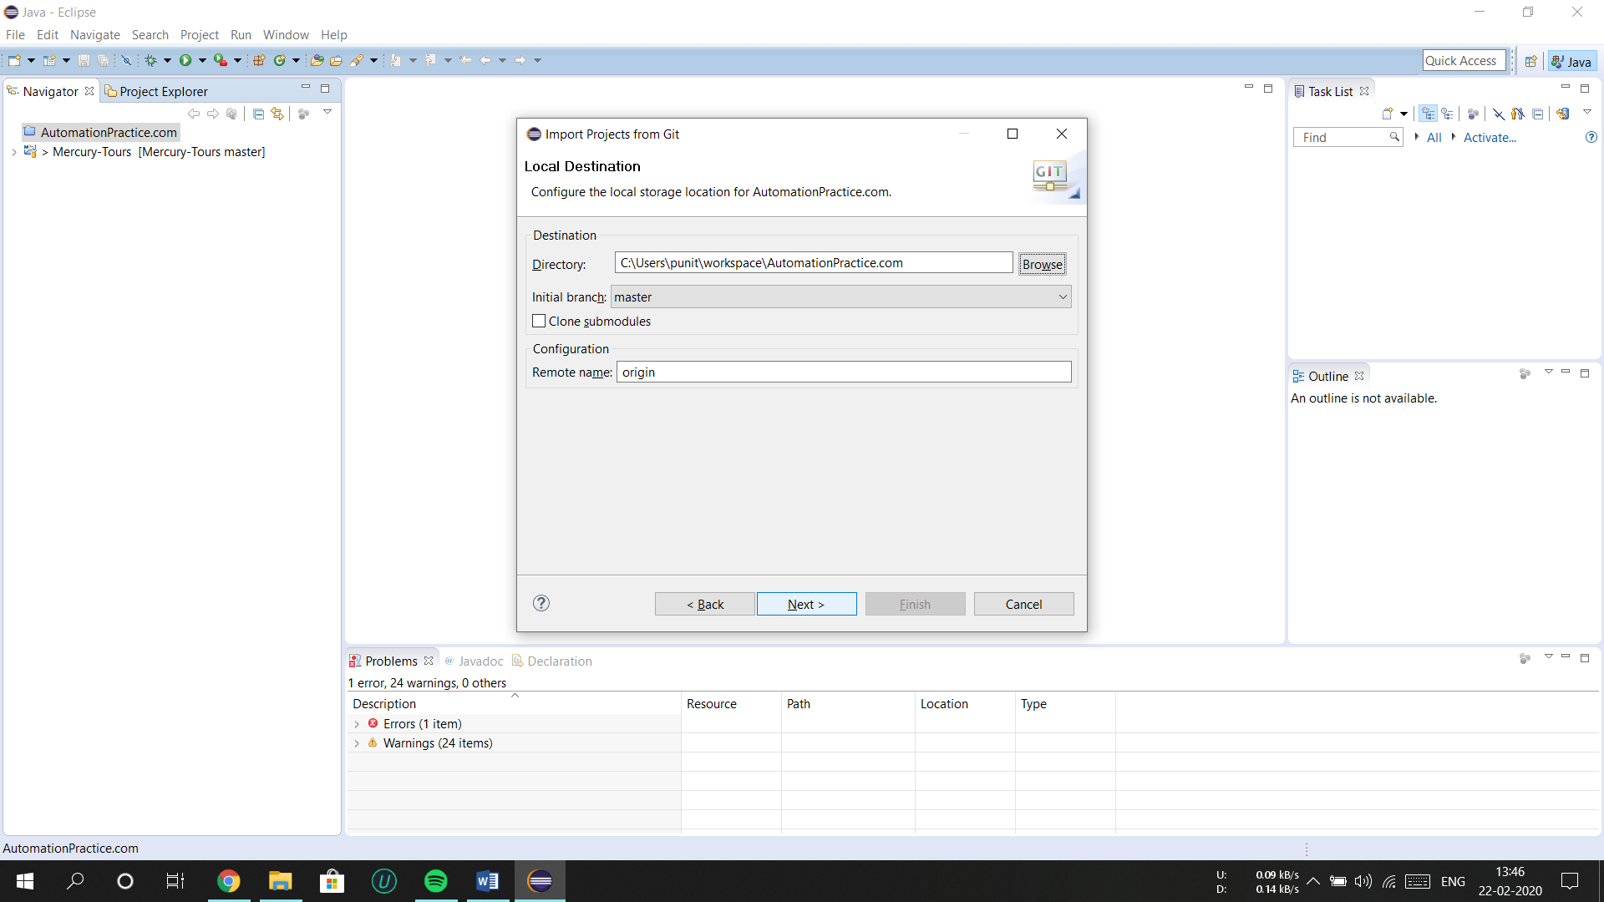

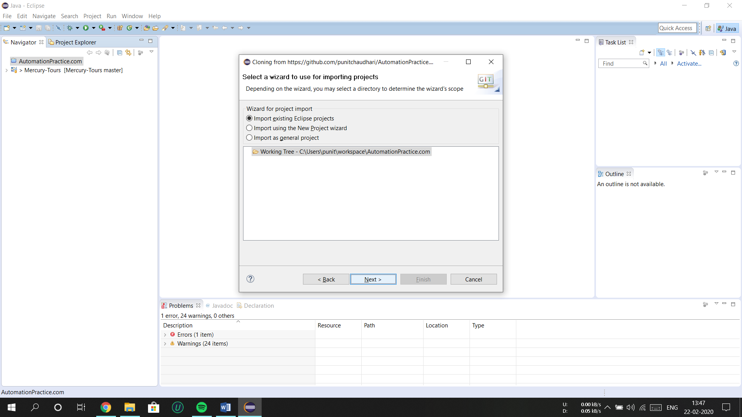

**Step 10:** click Finish

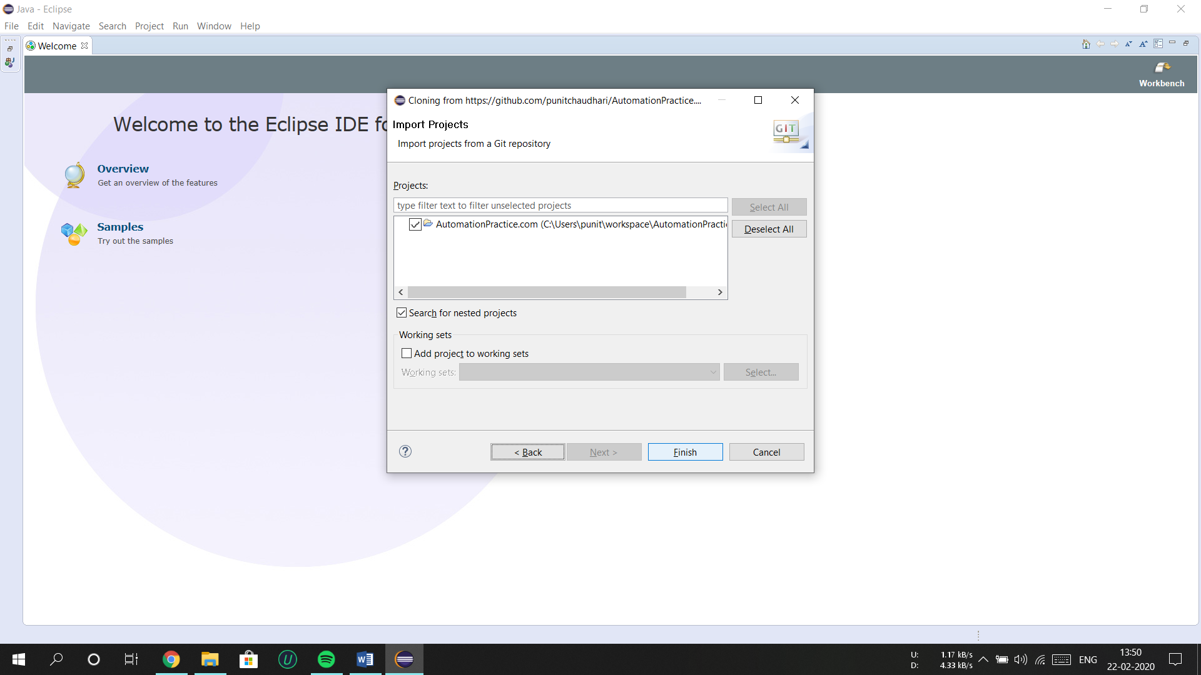

**Step 11:** make sure TestNG plugin is installed on eclipse,if not installed follow these steps

**Step 12:** go to help and choose option “Eclipse Maeketplace”

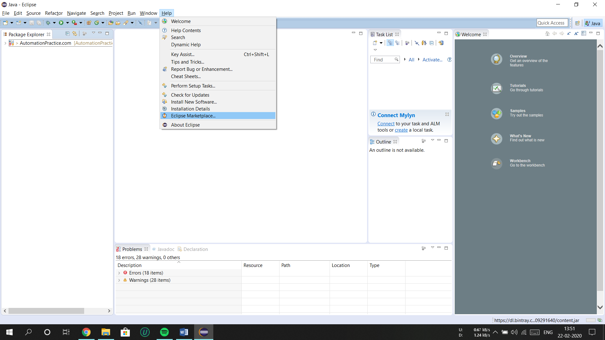

**Step 13:** type “TestNG” in search bar and install the TestNG plugin

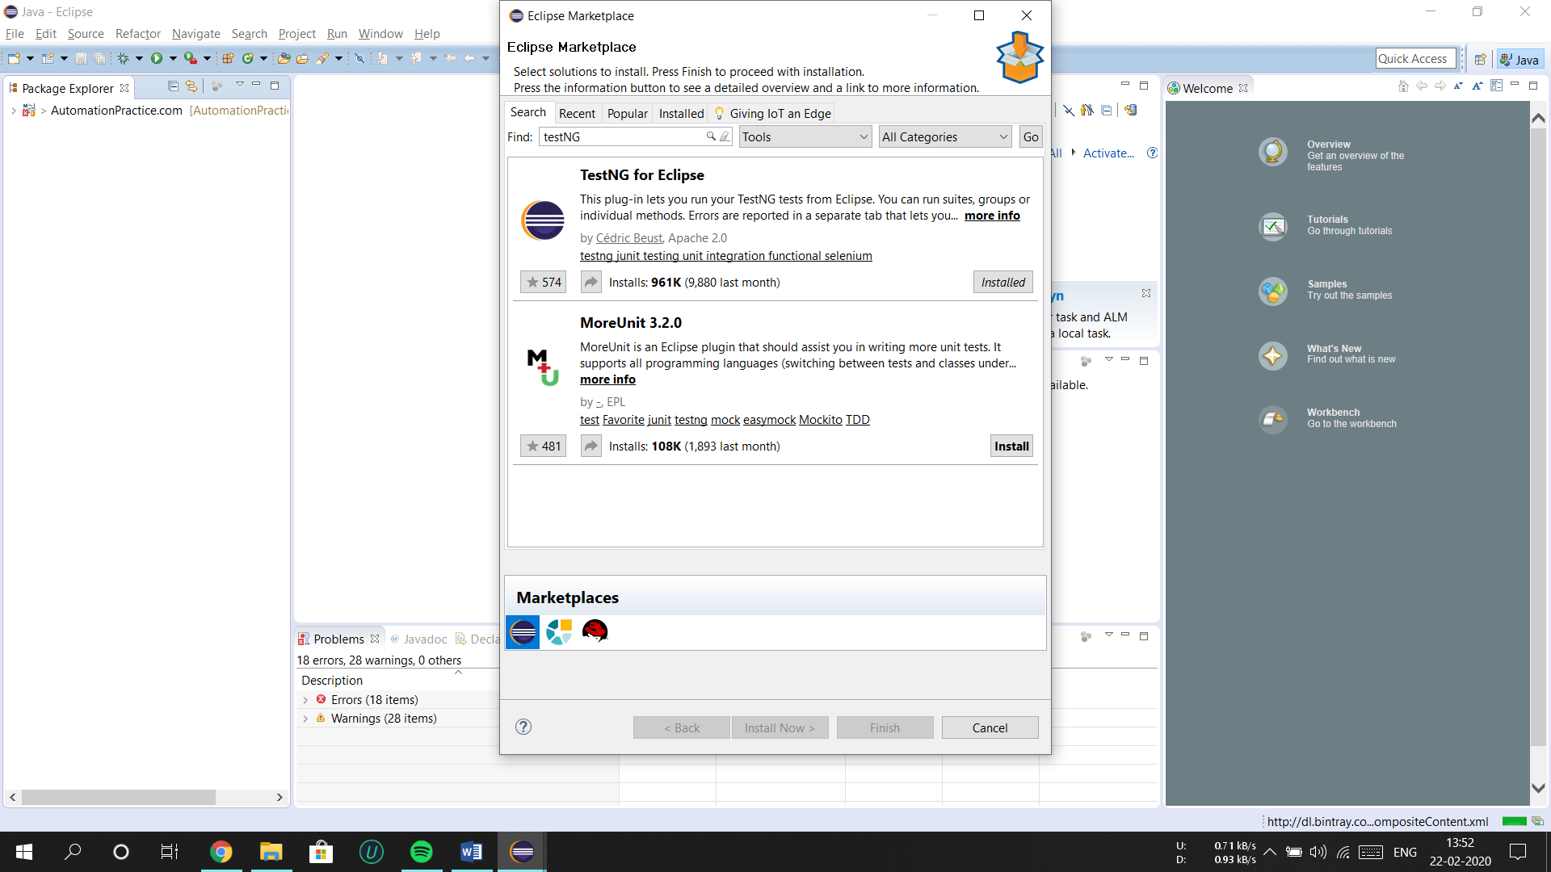

**Step 14:** make sure drivers for browsers are updated, these drivers version and Browser version which is installed on your system must be the same or the tests wont run.

**Step 15:** paste new drivers exe file in folder shown in screenshot below

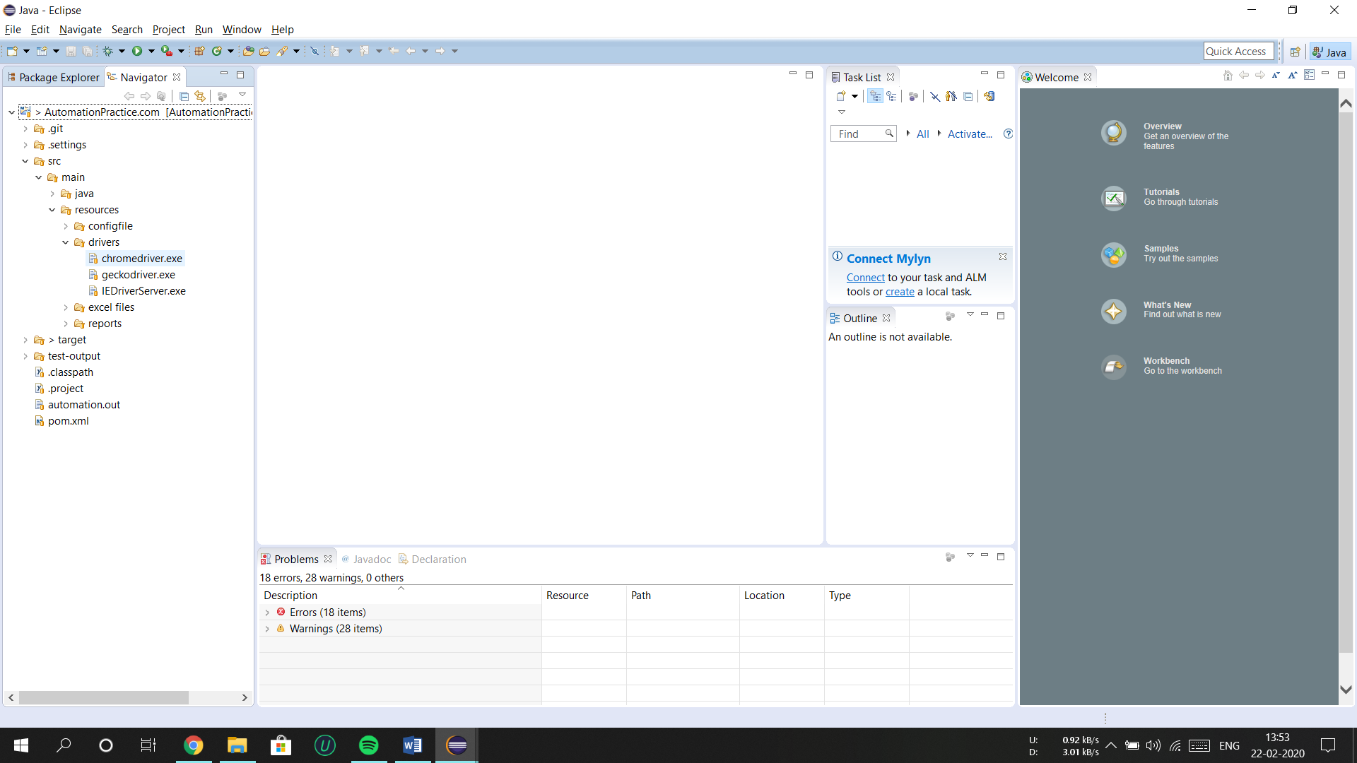

**Step 16:** now we are good to go unless you don’t have any errors in program . to run the Tests right click and choose ‘run as’>TestNg.

